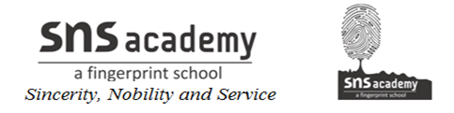

GRADE: IV NAME:
DATE: 18.11.20 SUB: SOCIAL
WORKSHEET- 14
OUR MINERAL RESOURCES

A. Choose the correct answers.

1. What is the process of digging ores out of the ground called?

a. irrigation b. industry c. farming d. mining

2. How many types of minerals are there?

a. two b. three c. four d. five

3. Which of these is a metallic mineral?

a. coal b. limestone c. bauxite d. salt

4. Which of these minerals is called fossil fuel?

a. iron b. coal c. diamond d. gold

5. Which of these is a coal-mining centre?

a. Dhanbad b. Digboi c. Haldia d. Barauni

6. Which of these is made from manganese?

a. utensil b. jewellery c. steel d. cement

B .Fill in the blanks.

1. An ---------------------- is a rock that contains a large amount of a particular mineral.

2. Precious stones are examples of ------------------- minerals.

3. ---------------------- is mined in Raniganj.

4. Petroleum is also known as -------------------------.

5. We get aluminium from ---------------------------.

6. -------------------------- and ------------------- are mined off the coast of Mumbai, in the Arabian Sea.

C. Match the columns.

1. natural gas a. jewellery

2. copper b. fuel

3. gold c. alloys

4. iron ore d. electrical wire

5. manganese e. machine

D. Write short answers.

1. What are metallic minerals?

------------------------------------------------------------------------------------------------

---------------------------------------------------------------------------------------------------

2. What is an oilfield?

--------------------------------------------------------------------------------------------------

----------------------------------------------------------------------------------------------------

3. Write the names of three things we get by refining petroleum.

----------------------------------------------------------------------------------------------------

----------------------------------------------------------------------------------------------------

4. Write the names of two states where coal is mined.
----------------------------------------------------------------------------------------------------

----------------------------------------------------------------------------------------------------

